FRIENDS OF SALISBURY CATHEDRAL 2020 Christmas card order form

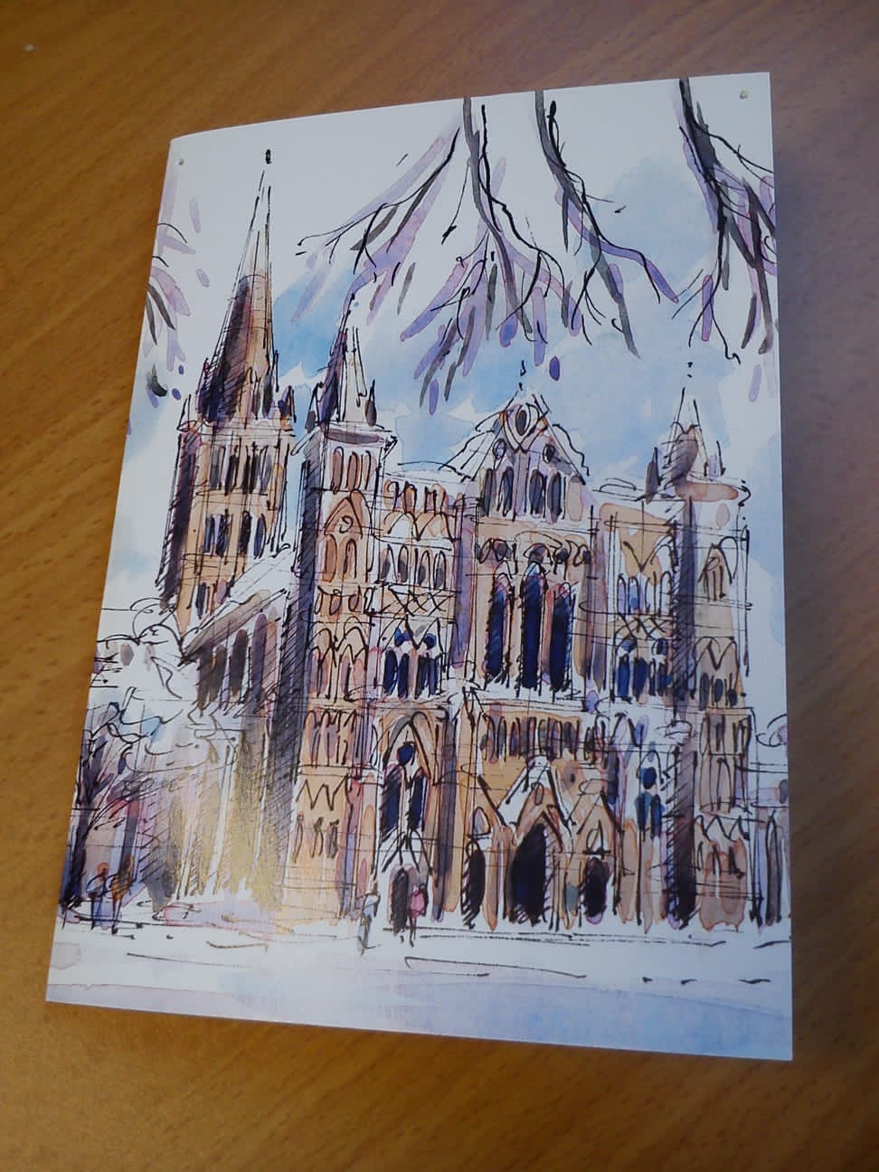

‘Winter wonderland, from an original watercolour by Richard Briggs

Greeting reads:
Best Wishes for Christmas and the New Year
£6 for pack of 8 cards 15cm x 10cm

FRIENDS OF SALISBURY CATHEDRAL - ORDER FORM 2020

33a The Close, Salisbury SP1 2EJ tel: (01722) 335161 email: friends@salcath.co.uk regd charity no: 243439

Your Name: ………………………………………………………………………………………………….………………………

Address: ……………………………………………………………………………………………………………………….

………………………………………………………………………… Post Code………….……………………………….

Telephone………………………………………………………….. e-mail………………………………………………...

Item | Price | Number required | Sub total
Christmas Card (pack of 8) | £6 | X packs | £
Add postage & packaging (see below for costs) |  |  | £
If you would like to make a donation, please add amount here |  |  | £
Tick if you wish to collect your order from the Friends’ Office
Grand Total to Pay |  |  | £

Cards also available from the Friends Office

cheques payable to: FRIENDS OF SALISBURY CATHEDRAL
or if you wish to pay by bank transfer please telephone the office for details.

Postage and Packing for UK CUSTOMERS ONLY

We try to keep the cost of postage & packing as low as possible
1 – 2 packs | £2
3 – 4 packs | £4
5 – 6 packs | £5
7+ packs | contact office

